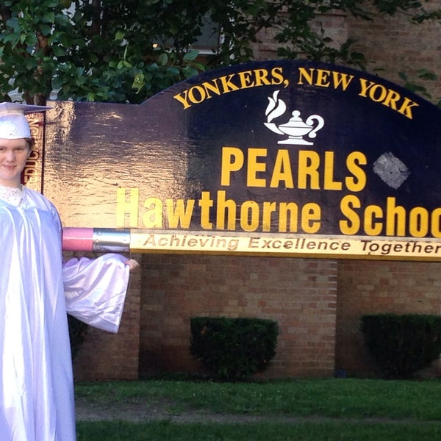

MINIMUM CAPACITY :-
The Minumum intake capacity
of students is between 300-620
children

LIBRARY :-
The Libarary is Available.

CANTEEN:-
The Canteen Facility is Available.

BOARDING :-
No availablility of boarding.

SPORTS :-
There are different categories
sports available.
Girls Volleyball
Boys Volleyball
Football

PEARLS HAWTHORNE SCHOOL
YONKERS - SCHOOL

School Detail :-
The mission of PEARLS Hawthorne School is to provide a safe, nurturing, and holistic learning environment for our diverse population. We strive to cultivate metacognitive skills and encourage self-directed learning. We aim to support positive character traits and community consciousness.

